
MAHATMA EDUCATION SOCIETY’S
PILLAI COLLEGE OF ARTS, COMMERCE & SCIENCE
(Autonomous)
NEW PANVEL

PROJECT REPORT ON
“MOVIE REVIEWS AND RATINGS ANALYSIS”

IN PARTIAL FULFILLMENT OF
Degree of Bachelor Of Science in Computer Science
SEMESTER III :-2025-2026

PROJECT GUIDE : PROF. SANJANA BHANGALE
SUBMITTED BY: Gopal Ingale
ROLL NO: 5296
DIVISION :- SYCS / A

Certificate

This is to Certify that MR. Gopal Ingale of S.Y.B.Sc. CS Semester IV has Completed the Practical work in the Subject of the Introduction to Data Science During the academic year 2025-2026 Under the Guidance of Prof. Sanjana Bhangale Mam Being the partial requirement for the Curriculum of Degree Of Bachelor Of Science in Computer Science , University Of Mumbai

Place:
Date:

Name & Signature of Faculty:

Name & Signature of External:

INDEX
Title | Page No.

Acknowledgement | 4
Data Description | 5
Data Analysis Questions | 6 - 14
Data Visualization Questions | 15 - 18
Conclusion | 19
References | 20

ACKNOWLEDGEMENT

To list who all have helped me is difficult because they are so numerous and the depth is so enormous. I would like to acknowledge the following as being idealistic channels and fresh dimensions in the completion of this project.
I would like to thank my Principal, Dr. Gajanan Wader for providing the necessary facilities required for completion of this project.
I take this opportunity to thank our Coordinator for her moral support and guidance.
I would also like to express my sincere gratitude towards my project guide Prof. Sanjana Mam whose guidance and care made the project successful.
Lastly, I would like to thank each and every person who directly or indirectly helped me in the completion of the project especially my Parents and Peers who supported me throughout my project.

DATASET DESCRIPTION

The dataset used in this project contains information about different movies, their ratings, financial performance, and audience reviews. The data helps in analyzing movie success based on ratings, budget, revenue, and viewer feedback.
For this project, the dataset includes the following main columns:
- movie_name – Name of the movie
- director – Director of the movie
- language – Language in which the movie was released
- runtime_minutes – Duration of the movie in minutes
- imdb_rating – IMDB rating of the movie
- rating – Certification category (U, UA, A)
- budget_crore_inr – Budget of the movie (in Crore INR)
- worldwide_revenue_crore_inr – Total worldwide revenue (in Crore INR)
- number_of_reviews – Total number of audience reviews
- streaming_platform – Platform where the movie is available
- review_date – Date when the review was recorded
Using this dataset, additional columns like profit and movie category (Poor, Average, Excellent) were created to perform better analysis and visualization.
The dataset is suitable for performing data cleaning, aggregation, grouping, and visualization tasks to understand patterns in movie performance and audience preferences.

DATA ANALYSIS QUESTIONS

Part A: Data Preparation & Cleaning (10 Questions)
1. Load the dataset using Pandas and display the first 5 rows.
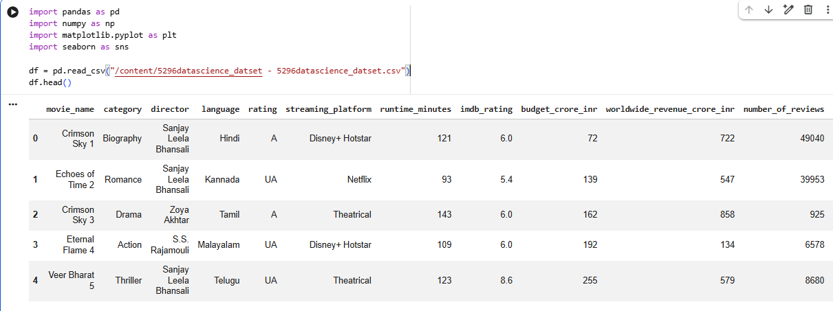

2. Check the dataset for missing values and identify which columns have nulls.
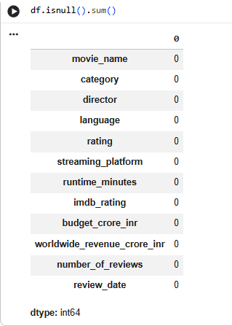
3. Display basic statistics (describe()) for numeric columns (runtime_minutes, imdb_rating, budget_crore_inr, worldwide_revenue_crore_inr, number_of_reviews).
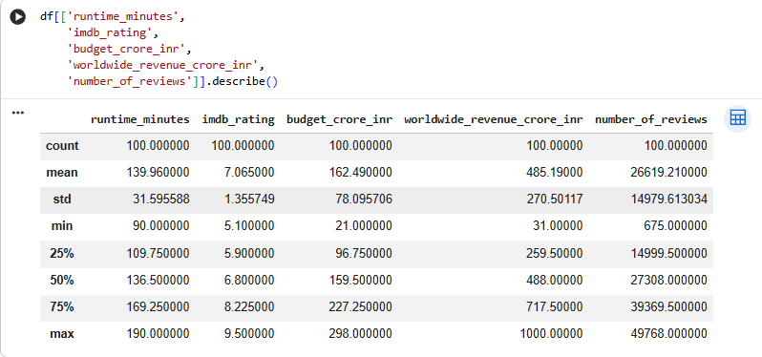

4. Convert review_date to datetime format.
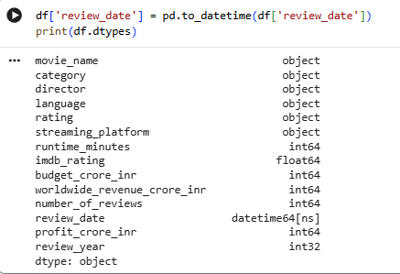

5. Check the number of unique movies, directors, and languages.
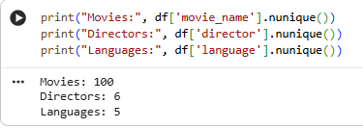

6. Standardize the rating column (A, UA, U) to consistent uppercase values.
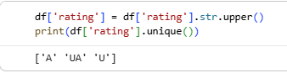

7. Remove any duplicate rows if present.
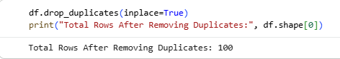

8. Add a new column profit_crore_inr = worldwide_revenue_crore_inr – budget_crore_inr.
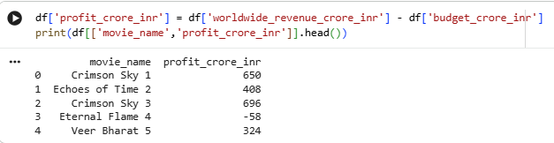

9. Categorize movies based on IMDB rating: Poor (<6), Average (6–7.5), Excellent (>7.5).
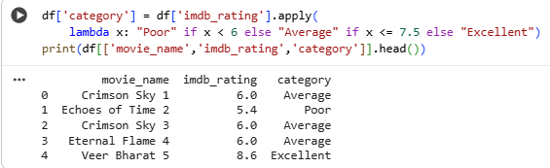

10. Extract the year from review_date into a new column review_year.
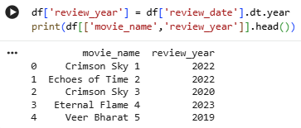

📊 Part B: Basic Data Analysis (10 Questions)
11. Count the number of movies in each category.
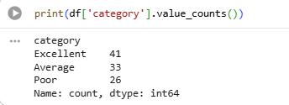

12. Find the average runtime of movies per category.
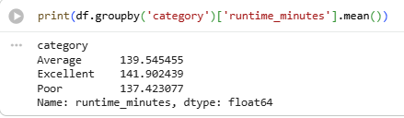

13. Identify the director who has made the most movies in the dataset.
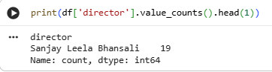

14. Calculate the average IMDB rating per language.
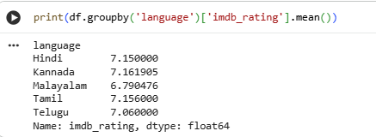

15. Find the movie with the highest worldwide revenue.
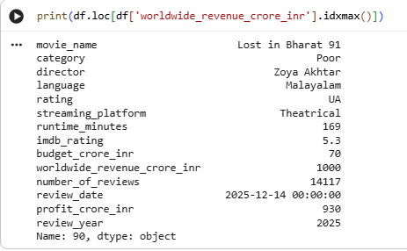
16. Find the movie with the lowest budget
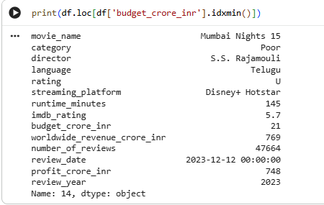

17. Find the average profit per category.
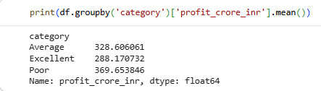

18. How many movies are available on each streaming_platform?
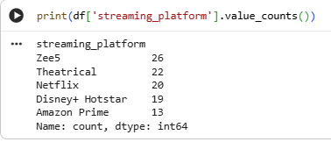

19. What is the average number of reviews per category?
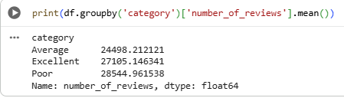

20. Find the top 3 directors with the highest average IMDB rating.
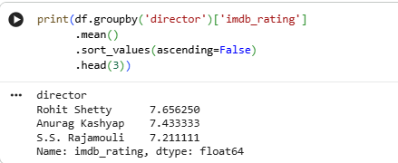

📊 Part C: Grouping & Aggregation (5 Questions)
21. Group movies by language and calculate the total worldwide revenue per language.
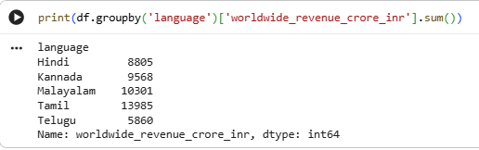

22. Group by rating and calculate the average runtime.
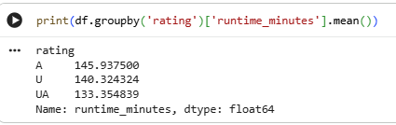

23. Group by streaming_platform and calculate the mean IMDB rating.
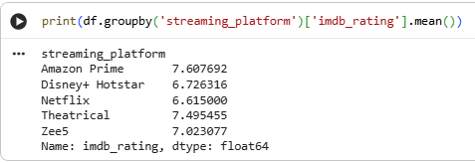

24. For each director, calculate the total number of reviews received.
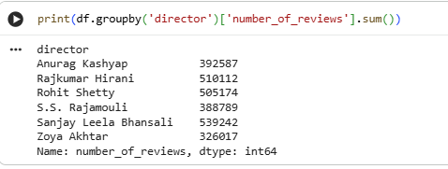

25. Group movies by category and calculate the mean profit.
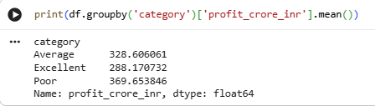
DATA VISUALIZATION QUESTION
📊 Part D: Data Visualization (10 Questions)
26. Plot a bar chart showing the number of movies per category.
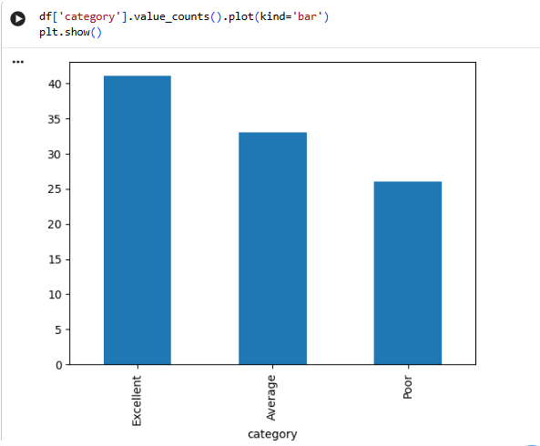

27. Create a histogram showing the distribution of imdb_rating.
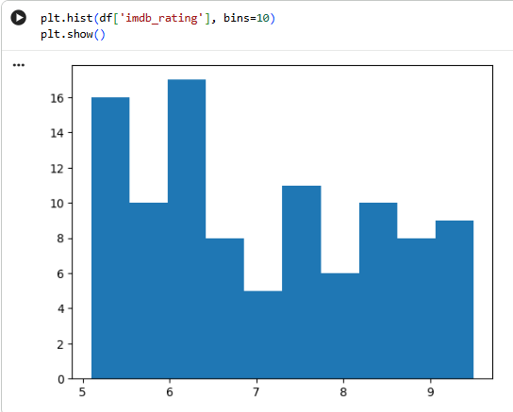
28. Create a boxplot of runtime_minutes per category.
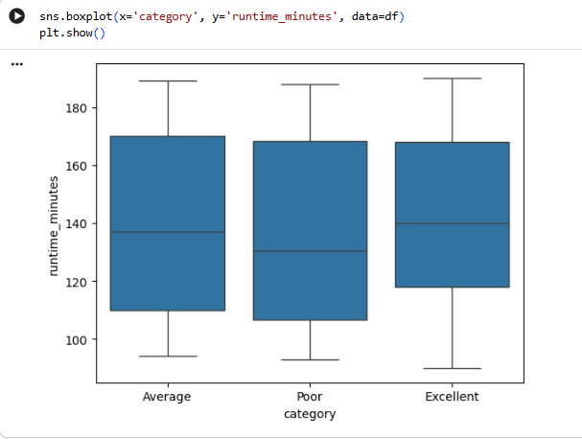

29. Plot a pie chart showing the proportion of movies per streaming_platform
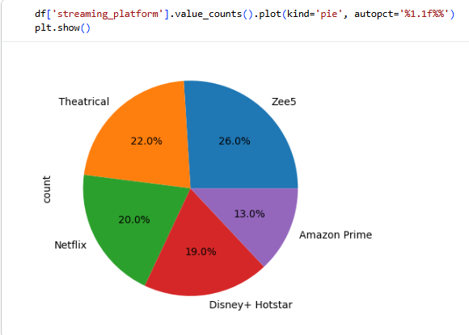

30. Draw a scatter plot of budget_crore_inr vs worldwide_revenue_crore_inr
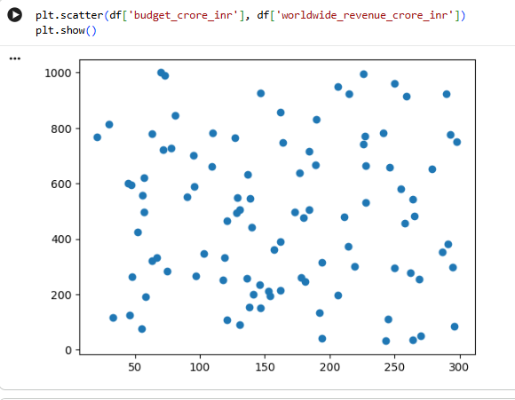

31. Use Seaborn to plot a countplot of movies per language.
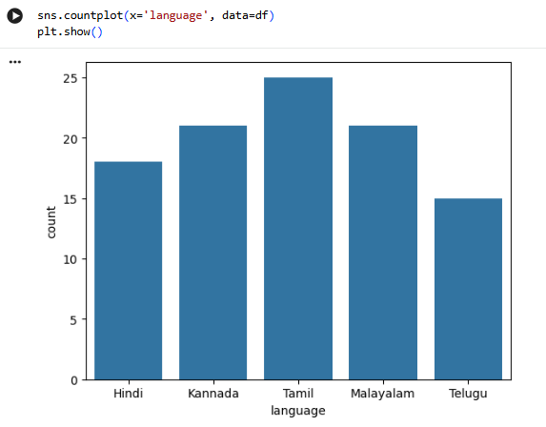

32. Draw a line plot showing the number of movies released per year
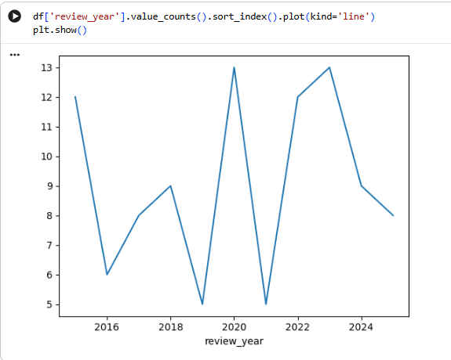

33. Create a barplot showing the average IMDB rating per category.
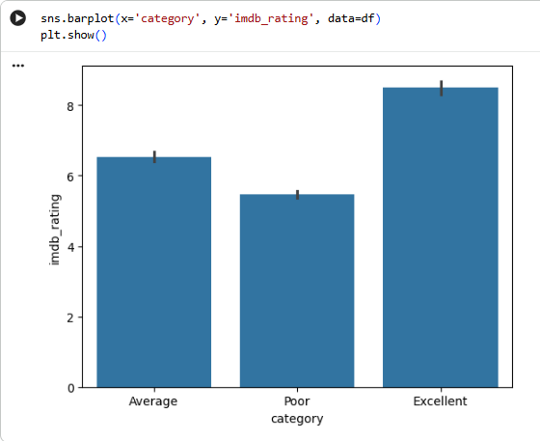

34. Plot a heatmap showing correlation between numeric columns (runtime_minutes, imdb_rating, budget_crore_inr, worldwide_revenue_crore_inr, number_of_reviews).
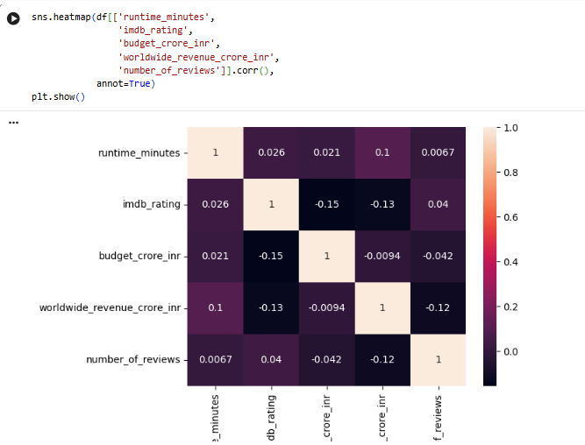

35. Create a scatterplot with hue for profit_crore_inr vs imdb_rating, colored by category.
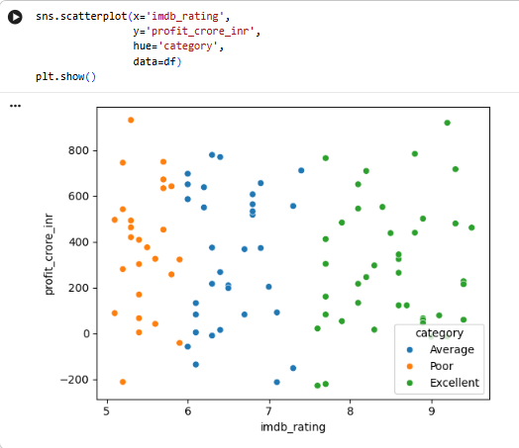
CONCLUSION

The project “Movie Review and Ratings Analysis” was successfully completed using data analysis and visualization techniques. By analyzing the dataset, meaningful insights were obtained regarding movie performance, audience preferences, and financial success.
Through data cleaning and preprocessing, the dataset was prepared for accurate analysis. Various operations such as grouping, aggregation, and visualization helped in identifying patterns between IMDB ratings, profit, runtime, language, and streaming platforms.
The analysis showed that movies with higher IMDB ratings generally tend to generate better revenue and profit. It was also observed that certain directors and languages consistently perform better in terms of ratings and audience reviews. Additionally, categorizing movies into Poor, Average, and Excellent helped in understanding overall movie quality distribution.
Overall, this project enhanced understanding of data analysis concepts such as data preprocessing, statistical analysis, and visualization using Python libraries like Pandas, Matplotlib, and Seaborn. The study demonstrates how data science techniques can be used to evaluate movie performance and support decision-making in the entertainment industry.

REFERENCES

- McKinney, W. (2018). Python for Data Analysis. O’Reilly Media.
- VanderPlas, J. (2016). Python Data Science Handbook. O’Reilly Media.
- Official Documentation of Pandas – https://pandas.pydata.org
- Official Documentation of NumPy – https://numpy.org
- Official Documentation of Matplotlib – https://matplotlib.org
- Official Documentation of Seaborn – https://seaborn.pydata.org
- IMDb Official Website – https://www.imdb.com
- Python Software Foundation. (2024). Python Documentation. https://docs.python.org

